A Report

On AI POWERED STUDENT PERFORMANCE AND ANALYTICS DASHBOARD

carried out as part of the course Emerging Tools and Technology(ET&T) Lab
Submitted by

Name of student

Saaransh Malik (23FE10CSE00781)
Arnav Juneja (23FE10CSE00237)

VI Semester

in partial fulfilment for the award of the degree

of

BACHELOR OF TECHNOLOGY

In

Computer Science & Engineering





Department of Computer Science & Engineering,
School of Computer Science and Engineering,
Manipal University Jaipur,
Jan-May 2026

ABSTRACT

The AI-Powered Student Performance Assessment and Analytics Dashboard is a web-based academic analytics system designed to monitor, analyze, and visualize student performance data. The project focuses on collecting and representing a broad student dataset including demographic details, academic scores, attendance, school and department information, behavior score, extracurricular participation, socioeconomic status, parental education, internet access, and career goals.
The system is developed using Flask, Python, Pandas, Plotly, HTML, CSS, and JavaScript. It offers an interactive dashboard with filtering options that allow users to analyze student records by school, department, grade level, region, gender, socioeconomic category, and internet access. The project also includes AI-inspired insight generation for identifying high-performing students, at-risk learners, and academic intervention needs.
The project integrates major technical components such as data visualization, introductory LLM-style insight generation, Docker-based containerization, Kubernetes deployment support, and Tableau-ready data export, making it a strong capstone-level application. The system helps educational stakeholders make informed decisions regarding student performance, intervention, and planning.

TABLE OF CONTENTS
Section | Title
1 | Introduction
2 | Design Description
3 | Project Description
4 | Input/Output Form Design
5 | Testing and Tools Used
6 | Implementation and Maintenance
7 | Conclusion and Future Work
8 | Outcome
9 | Bibliography

1.1 Objective of the Project
The main objective of this project is to build an intelligent and interactive student performance dashboard that can:
• store and process student-related academic and contextual data.
• visualize performance trends using charts and analytics.
• identify students requiring academic support.
• generate insight-based recommendations.
• help in educational monitoring and decision-making.
1.2 Brief Description of the Project
This project is a web-based dashboard application that manages and analyzes student performance assessment data. The system uses a dataset of 100 unique students and includes a wide variety of fields such as academic marks, attendance, behavior, extracurricular participation, demographic information, school information, and support-related indicators.
The dashboard provides real-time filtering of student data, spotlight view of an individual student, cohort-level performance comparison, support-risk identification, and academic analytics through interactive visualizations.
1.3 Technology Used
Component | Technology Used
Frontend | HTML, CSS, JavaScript
Backend | Python Flask
Data Handling | Pandas
Visualization | Plotly
Testing | Pytest
Containerization | Docker, Docker Compose
Deployment | Kubernetes manifests
Analytics Integration | Tableau-ready export

1.3.1 Hardware Requirement
Hardware | Specification
Processor | Intel Core i3 or above
RAM | Minimum 4 GB, recommended 8 GB
Storage | Minimum 500 MB free space
Display | 1366 x 768 resolution or above

1.3.2 Software Requirement
Software | Requirement
Operating System | Windows / Linux / macOS
Python | 3.11 or above
Libraries | Flask, Pandas, Plotly, Gunicorn, Pytest
Tools | Docker Desktop, Kubernetes, VS Code
Browser | Chrome / Edge / Firefox

1.4 Organization Profile
This project is developed as an academic application under the Department of Computer Science and Engineering, Manipal University Jaipur. The work is intended for educational analysis and demonstration of student performance monitoring using modern software engineering and analytics tools.

2. DESIGN DESCRIPTION
2.1 Flow Chart
• Start
• Load Student Dataset
• Process and Clean Data
• Compute Academic Averages and Indicators
• Generate Insights and Risk Flags
• Render Dashboard
• Apply Filters
• Update Charts and Student Spotlight
• Display Results
• End

2.2 Data Flow Diagrams
Level 0 DFD: User interacts with the Student Performance Dashboard System, which reads the student dataset and produces reports and visualizations.

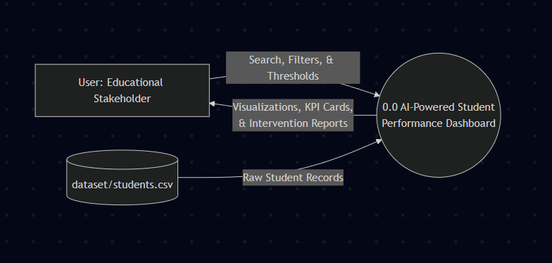
Level 1 DFD: User applies filters and inputs, the Data Processing Module reads the dataset, and the Insight Generation Module and Visualization Module produce recommendations and charts for the user.

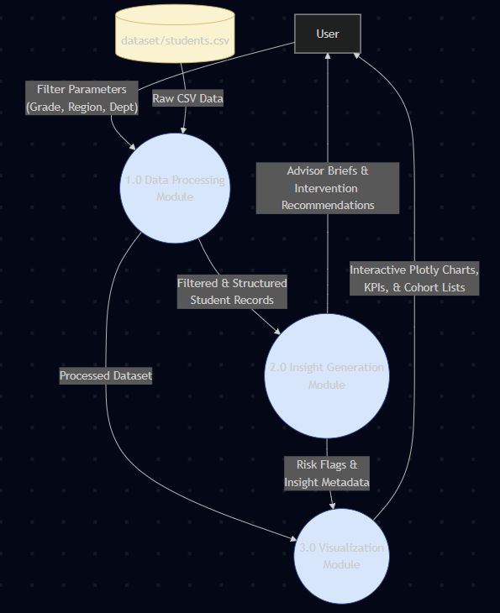

2.3 Entity Relationship Diagram
The current system uses a CSV-based student entity containing StudentID, Student, Gender, Age, GradeLevel, School, Department, Region, SocioeconomicStatus, ParentalEducation, StudyHoursPerWeek, Attendance, Math, Science, English, ComputerScience, Economics, BehaviorScore, ExtracurricularScore, InternetAccess, CareerGoal, and Average.

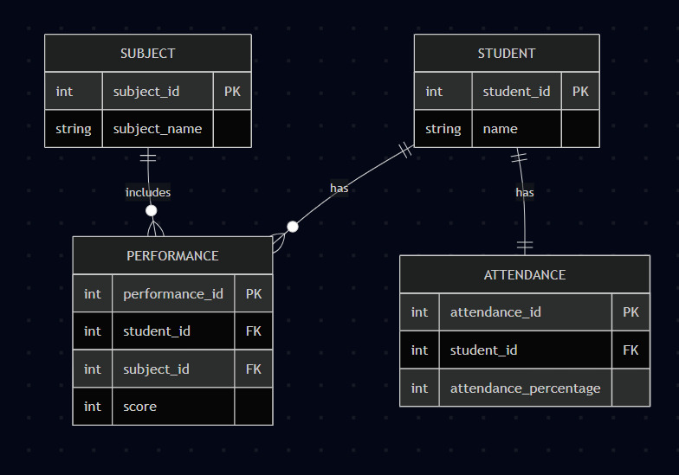

3. PROJECT DESCRIPTION
3.1 Database
This project currently uses a CSV file-based dataset instead of a traditional relational database. The main dataset file is dataset/students.csv. Data is loaded using Pandas and processed dynamically inside the Flask application.
3.2 Table Description
Field Name | Description
StudentID | Unique student identifier
Student | Name of student
Gender | Gender of student
Age | Age of student
GradeLevel | Class or grade level
School | School name
Department | Department or stream
Region | Urban or Rural
SocioeconomicStatus | Student socioeconomic category
ParentalEducation | Parent education level
StudyHoursPerWeek | Weekly study hours
Attendance | Attendance percentage
Math / Science / English / ComputerScience / Economics | Assessment scores
BehaviorScore | Behavioral performance score
ExtracurricularScore | Participation/activity score
InternetAccess | Internet access status
CareerGoal | Student career aspiration
Average | Calculated overall academic average

3.3 File/Database Design
• app.py - Main Flask application
• llm_assistant.py - AI-style insight generation logic
• dashboard/visualizations.py - Plotly chart generation functions
• templates/index.html - Dashboard frontend template
• dataset/students.csv - Main student dataset
• tests/test_app.py - Unit tests
• Dockerfile - Containerization setup
• docker-compose.yml - Docker compose configuration
• kubernetes/ - Deployment manifests

4. INPUT/OUTPUT FORM DESIGN
Input controls include student search, school filter, department filter, grade filter, region filter, gender filter, socioeconomic filter, internet access filter, attendance threshold slider, support-risk toggle, and sorting dropdown.
Output is displayed in the form of KPI metric cards, student spotlight panel, advisor brief and intervention recommendations, cohort explorer student list, intervention matrix chart, subject balance chart, server-rendered Plotly visualizations, and cohort directory table.
5. TESTING AND TOOLS USED
Testing covers the following application checks:
• successful loading of dataset
• generation of average column
• uniqueness of student names
• correct Urban/Rural region setup
• rendering of dashboard home page
• API response validation
• Tableau export route validation

Tools used in the project include:
• Python
• Flask
• Pandas
• Plotly
• Pytest
• Docker and Docker Compose
• Kubernetes
• VS Code
• Git/GitHub
6. IMPLEMENTATION AND MAINTENANCE
The implementation of the project follows a modular structure. Backend logic is handled using Flask routes, data processing is done through Pandas, charts are built using Plotly, and the frontend is created using HTML, CSS, and JavaScript. Dynamic filtering is implemented on the client side for interactivity.
For maintenance, the dataset can be updated by replacing the CSV file, the system supports containerized deployment using Docker, Kubernetes manifests allow future scalable deployment, and test files help ensure correctness after code updates.
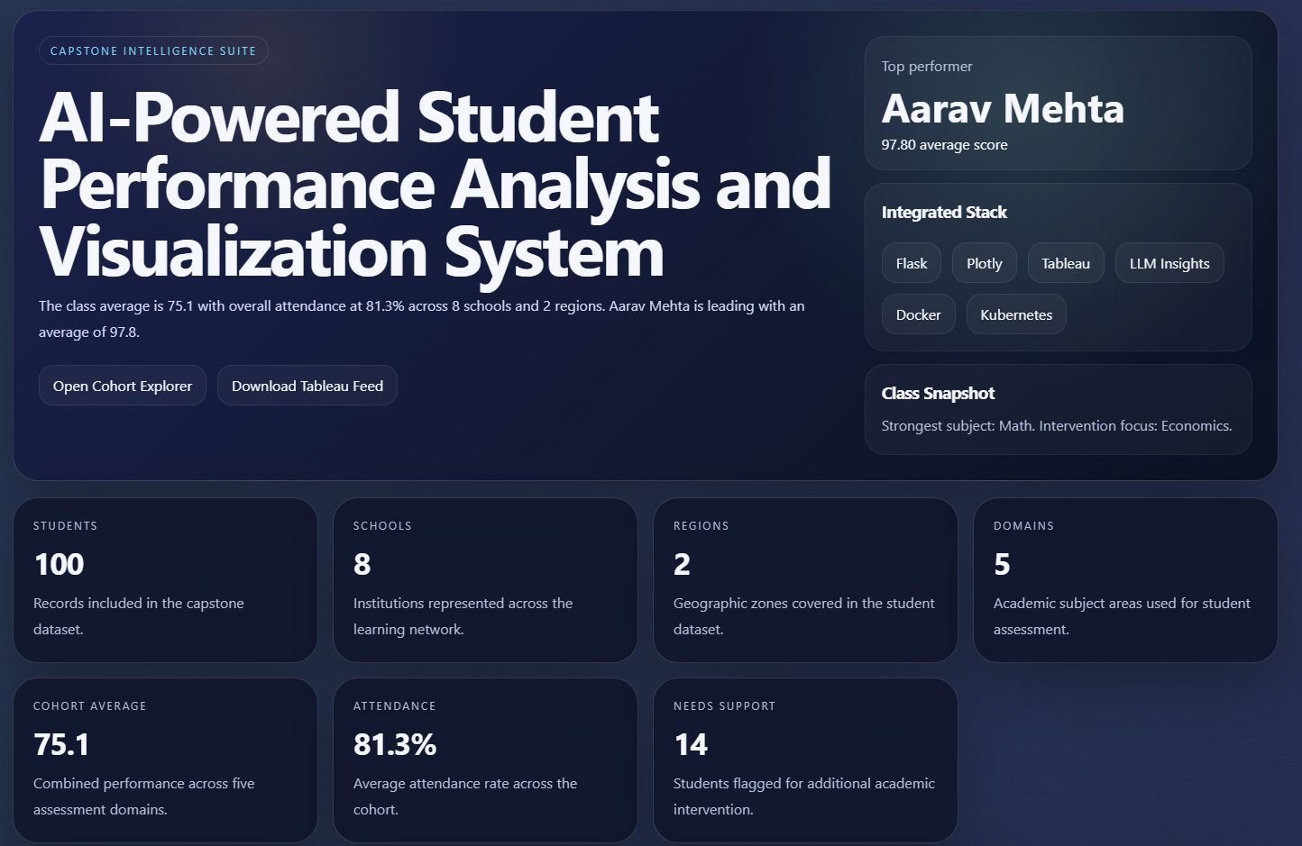

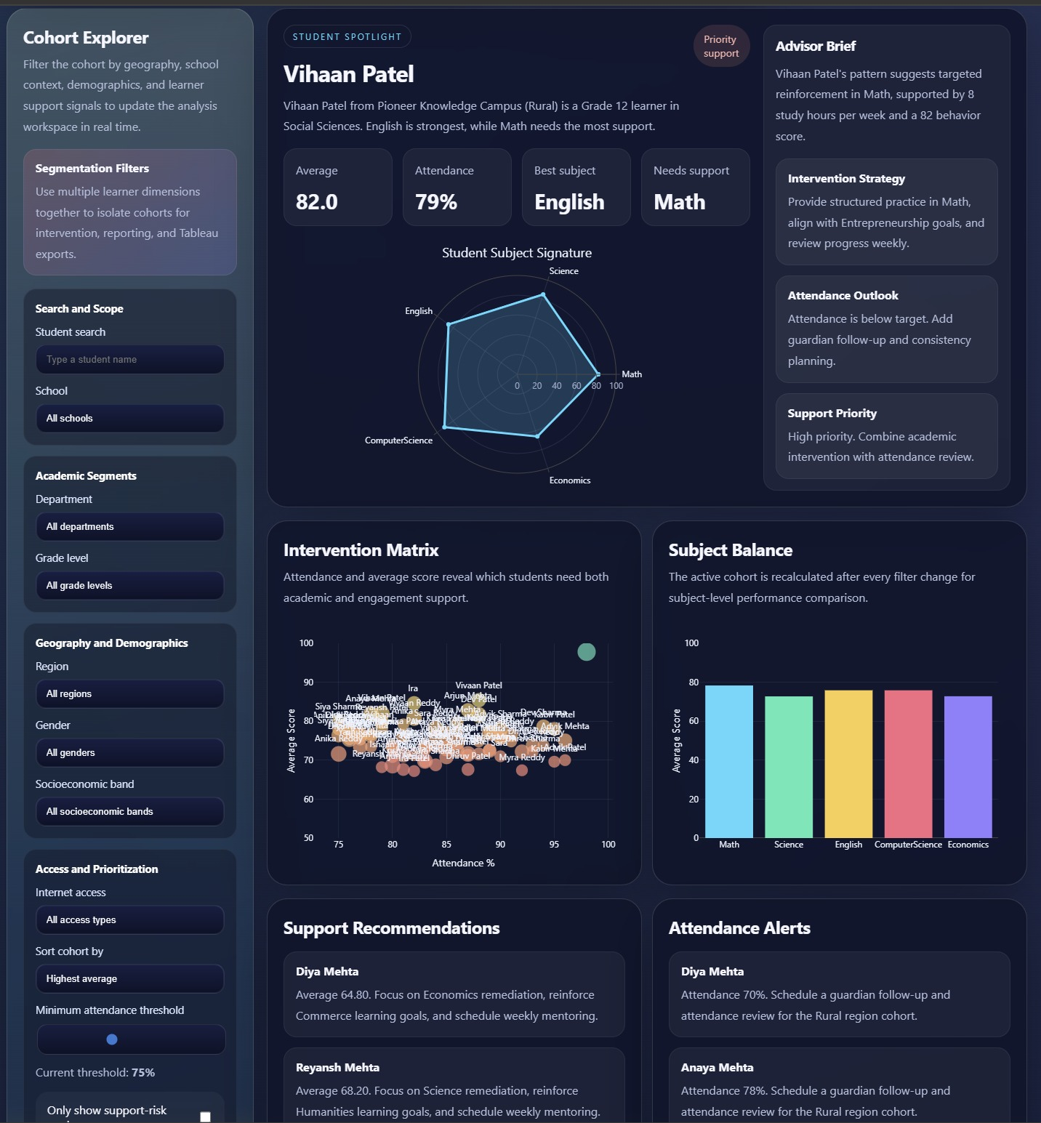

7. CONCLUSION AND FUTURE WORK
The project successfully demonstrates a complete student performance analytics system that combines data management, visualization, filtering, and intelligent insight generation. It provides a rich and interactive dashboard for understanding academic trends, attendance behavior, learner support needs, and student segmentation.
Future enhancements may include:
• integration with a relational database such as MySQL or PostgreSQL
• login and role-based access control
• downloadable PDF report generation
• historical trend analysis across semesters
• real LLM/API integration for advanced recommendations
• teacher/admin dashboards
• predictive analytics using machine learning
• live deployment on cloud platforms
8. OUTCOME
The project has reached a functional stage with a fully working dashboard, expanded dataset, multi-factor filtering, interactive charts, and deployment-ready configuration.
The work demonstrates progress toward a capstone-level educational analytics system with strong visualization and insight-generation capabilities.
Further outcomes may include deployment, publication as a technical paper, or extension into a full-scale academic monitoring platform.

9. BIBLIOGRAPHY
• [1] Grus, J. (2019). Data Science from Scratch. O'Reilly Media, Sebastopol, Calif.
• [2] McKinney, W. (2022). Python for Data Analysis. O'Reilly Media, Sebastopol, Calif.
• [3] Ramalho, L. (2022). Fluent Python. O'Reilly Media, Sebastopol, Calif.
• [4] Plotly Technologies Inc. (2024). Plotly Python Graphing Library. https://plotly.com/python/
• [5] Flask Documentation. (2024). Flask Web Development Framework. https://flask.palletsprojects.com/
• [6] Pandas Documentation. (2024). Pandas User Guide. https://pandas.pydata.org/
• [7] Docker Documentation. (2024). Docker Overview. https://docs.docker.com/
• [8] Kubernetes Documentation. (2024). Kubernetes Concepts. https://kubernetes.io/docs/home/

